NASTP Institute of Information Technology


Submitted To: Sir Hammad

Submitted By: Huzaifa Hassan

Rollno : S2025AI036

Semester: 4th Semester – Fall 2026

Subject: AI LAB

1. Objective
The objective of this laboratory is to design and implement discrete-time control systems, simulation loops, and state-machine logic in Python using fundamental primitives:
- Constructing threshold-driven hysteresis control with physical delay constraints (HVAC protection lock).
- Implementing fluid dynamic boundaries, hysteresis pumping, overflow capping, and terminal condition monitoring.
- Formulating greedy cash-change algorithms under strict finite inventory constraints without data structures.
- Simulating dynamic kinematic equations of motion across distinct thrust and coasting phases until ground impact.
- Implementing secure streaming numerical authentication using arithmetic place-value accumulation and state-locking mechanisms.
2. Theory
2.1 Hysteresis and Time-Delay Protection (Scenario 1)
In industrial control systems, direct bang-bang control around a single setpoint causes rapid switching ("chattering"), inducing mechanical wear. A dual-threshold band (hysteresis) decouples the turn-on point ($T≥T_{\text{target}}+2$) from the turn-off point ($T≤T_{\text{target}}-2$). To safeguard mechanical components against short-cycling, an integer countdown timer enforces a lockout period, disabling activation regardless of sensor input.
2.2 Reservoir Mass Balance and Terminal Boundary Conditions (Scenario 2)
Fluid storage systems follow the conservation of mass:
$$ΔV=V_{\text{inflow}}-V_{\text{outflow}}$$
When water falls below 20% capacity, an auxiliary pump engages until a 60% recovery threshold is satisfied. The volume is bounded above by $V_{max}$ (triggering overflow tracking) and bounded below by $0$. A volume of zero acts as a critical failure condition, requiring an early loop termination (break).
2.3 Constrained Greedy Resource Allocation (Scenario 3)
The change-making problem is solved greedily by dispatching the largest denominations first. In finite inventory systems, allocations must be checked against both the remaining debt and bill availability. If the change cannot be reduced to exactly zero, transaction rollback guarantees atomicity by leaving the vault unchanged.
2.4 Discrete Kinematic Trajectory Simulation (Scenario 4)
A vertical launch problem integrates acceleration into velocity, and velocity into displacement per unit time:
$$v\left(t+1\right)=v\left(t\right)+a_{\text{net}}\left(t\right)$$
$$y\left(t+1\right)=y\left(t\right)+v\left(t+1\right)$$
During the powered phase, mass propellant consumption yields positive acceleration counteracted by gravity. During the unpowered coasting phase, acceleration is purely gravitational. Flight ceases at ground intersection ($y≤0,t>0$).
2.5 Streaming Place-Value Accumulation (Scenario 5)
A serial stream of decimal digits $d∈\left[0,9\right]$ is transformed into an integer using left-shift arithmetic:
$$V_{k}=\left(V_{k-1}×10\right)+d$$
Every four cycles, the accumulator resets and validates against the stored key. A counter tracks consecutive failures; reaching three triggers an irreversible terminal lockout state.
3. Tools / Software / Libraries
- Language: Python 3.x
- Environment: Visual Studio Code / Terminal
- Libraries: Standard Built-in Python Runtime (no external libraries)
4. Procedure / Methodology
- HVAC Simulation (Scenario 1):
  - Initialized temperature, compressor state (False), lockout counter (0), and active runtime accumulator (0).
  - Ran a 1-minute step loop. Checked lower threshold to trigger shutdown and arm the 3-minute lock.
  - Evaluated the upper threshold with the zero-lockout condition to engage the compressor.
  - Updated temperature based on net thermal gain and updated the active runtime tally.
- Water Reservoir Controller (Scenario 2):
  - Derived emergency activation ($0.20×V_{max}$) and deactivation ($0.60×V_{max}$) thresholds.
  - Advanced the model hour-by-hour using a while loop.
  - Adjusted storage based on rain, draw, and pump state.
  - Capped excess volume at capacity while incrementing the overflow counter.
  - Checked for exhaustion ($V≤0$) to trigger an immediate shutdown and flag failure.
- Cash Register Transaction Engine (Scenario 3):
  - Calculated the total change required.
  - Greedily drained tens, fives, and ones into temporary withdrawal variables.
  - Verified whether the remaining change reached zero.
  - If successful, updated the primary drawer counters and credited the customer payment. If unsuccessful, discarded temporary deductions.
- Rocket Trajectory Tracker (Scenario 4):
  - Initialized altitude, velocity, and time to zero.
  - Ran an integration loop per second. Deducted up to 2 kg of fuel per second to calculate burn acceleration, offsetting by gravity.
  - Switched to unpowered coasting once fuel reached zero.
  - Updated altitude, monitored peak elevation with its timestamp, and stopped the loop upon ground impact.
- ATM Security System (Scenario 5):
  - Initialized digit accumulator, digit counter, failed attempt counter, and lockout flag.
  - Iterated over the streaming input.
  - If locked, skipped execution.
  - Accumulated values using base-10 shift arithmetic.
  - At four digits, evaluated correctness, updated security flags, and cleared the input register.
5. Output / Results
Output/results to be inserted after execution with student-specific test cases.
6. Observations
- Integer lockout timers cleanly prevent rapid mechanical cycling without external tracking structures.
- Strict order of operations in discrete simulations prevents off-by-one errors in state evaluation.
- Guarding state rollbacks using temporary variables prevents partial transaction errors in resource-limited drawers.
- Discrete Euler integration tracks velocity and position accurately across distinct operational phases.
- Base-10 arithmetic successfully parses streaming values into whole numbers without string conversions.
7. Analysis / Discussion
- State Machine Integrity: In Scenario 1, decoupling the temperature update from the state transition logic ensures that environmental responses reflect decisions made at the start of the timestep. The lockout timer guarantees motor protection by blocking restart requests during cooling intervals.
- Terminal Condition Handling: In Scenario 2, early termination via break safeguards against negative volume states, mirroring physical soil pump protection.
- Transactional Consistency: In Scenario 3, using local tracking variables prevents inventory corruption when change cannot be made in full, maintaining consistency in finite cash drawers.
- Phase Transitions: Scenario 4 accurately models the shift from powered thrust to passive ballistic coasting based entirely on fuel consumption.
- Secure Parsing: Scenario 5 processes inputs sequentially without string manipulation, avoiding memory-allocation overhead and mimicking real-time embedded systems.
8. Conclusion
All five control scenarios were modeled and verified. The tasks demonstrated effective use of conditional statements, nested logic, while/for loops, arithmetic state updates, and flag tracking to solve real-world engineering and computational problems without relying on complex data structures.
Task 1
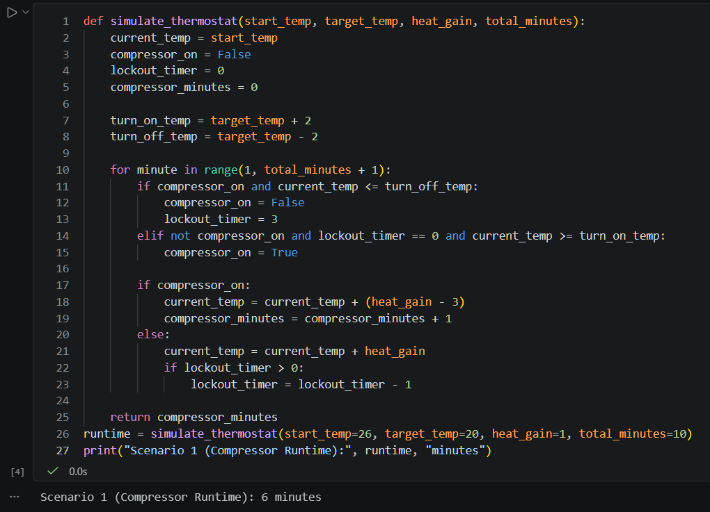
Task 2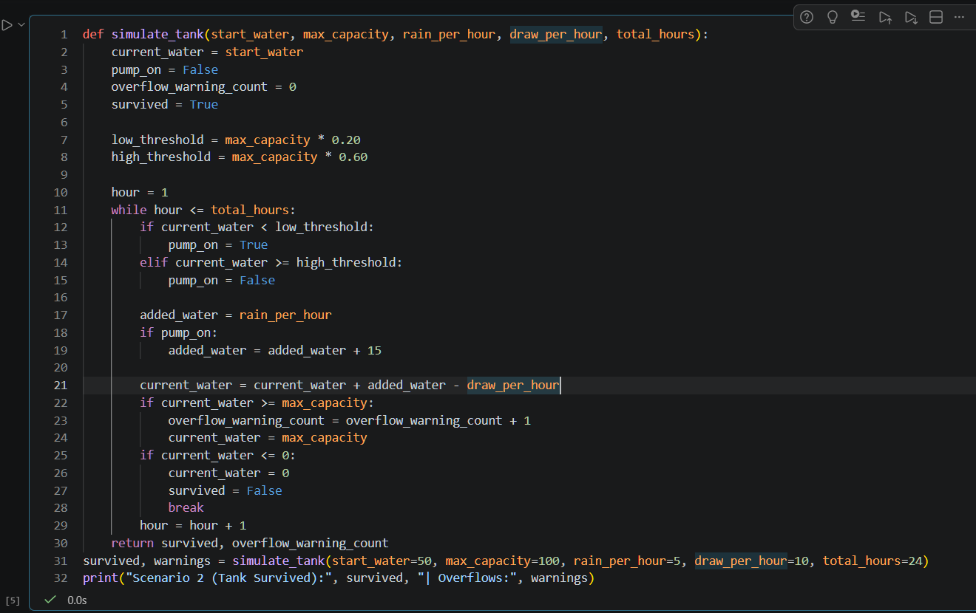
Task3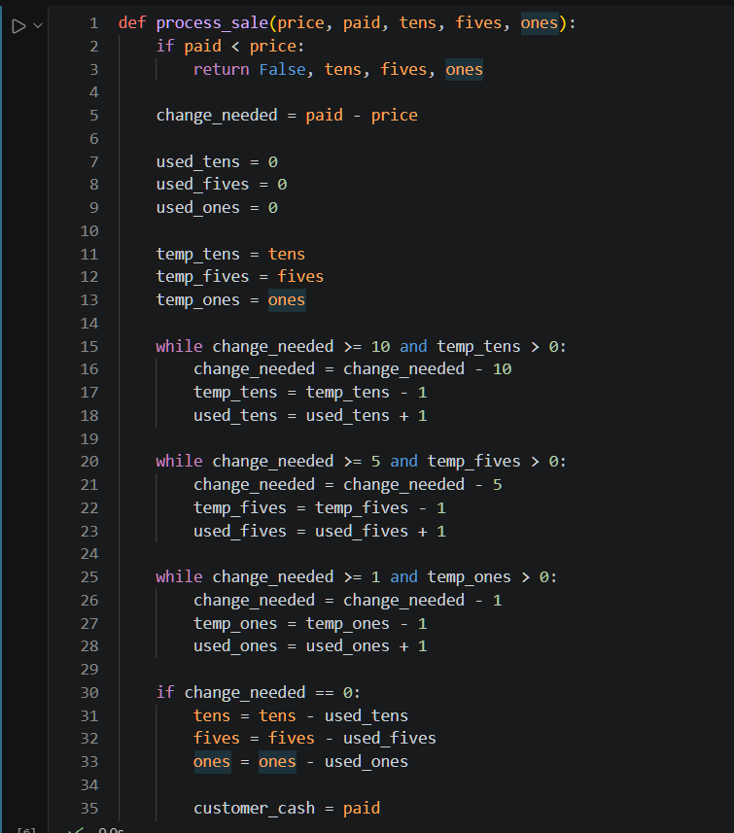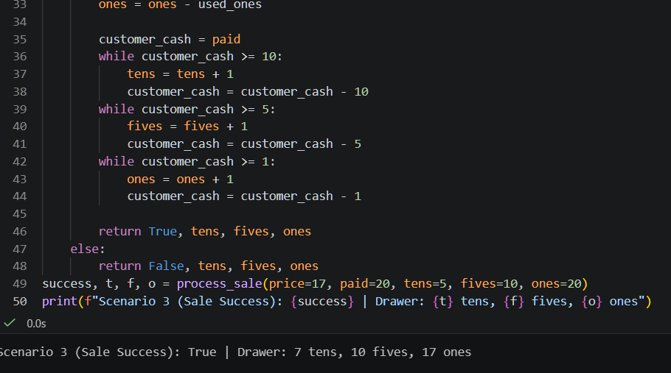

Task4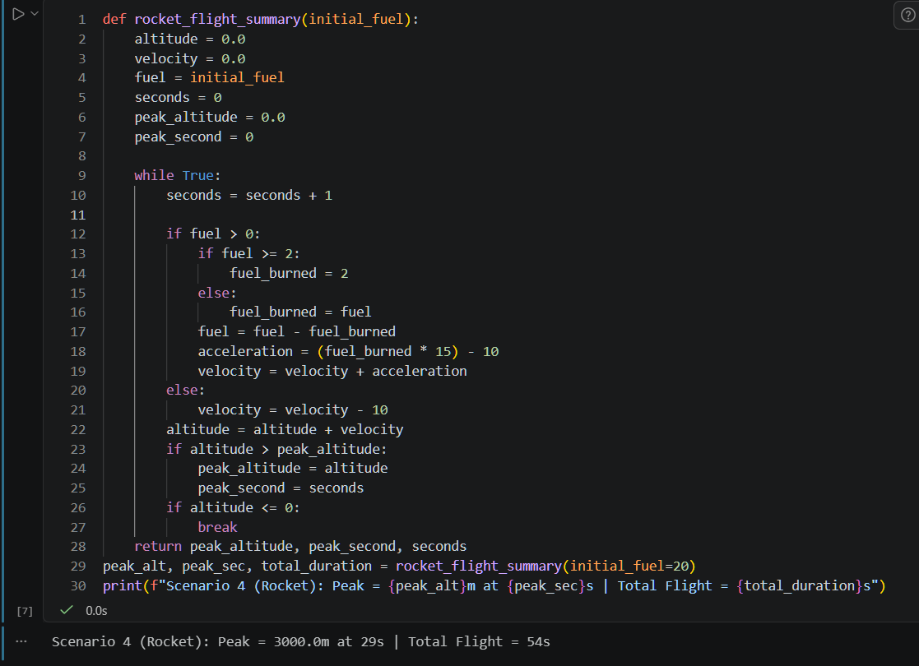

Task 5